**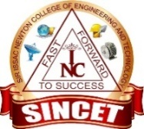****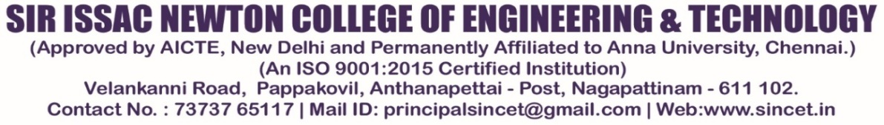**

**DEPARTMENT OF ARTIFICIAL INTELLIGENCE AND DATASCIENCE**

**INTERNAL GUEST LECTURE**

**co-ordinator: Ms.R.SINDHUJA, AP/ AI&DS**

**REPORT**

The Department of Atificial Intelligence and DataScience, conducted an Internal Guest Lecture for II year, III year & IV year AI&DS students. The program period on 24.09.2024 from 10.30am to 12.30 pm, the topic of the Program **“Internal Guest Lecture”** has delivered the importance of research of research in the academic and professional development of our students.

The **“Dr.H.Prabavathi”** Assistant Professor served as the Resource Person for the event. She discussed the Introduction and importance of “AI&DS in the field of research”. The Presenter content was good and students are very interesting to understand the various research methodologies and techniques, encouraging students to adopt a structured approach to their academic projects and future research endeavors.

A program title as **“Future of AI&DS in Healthcare and Military”** has been conducted at the beginning of the semester and the session was highly interactive, with students actively participating in the discussions, it received positive feedback from the attendees. This Guest lecture aimed to strengthen the research culture among the students of AI&DS Department.

**INTERNAL GUEST LECTURE-PHOTOS**

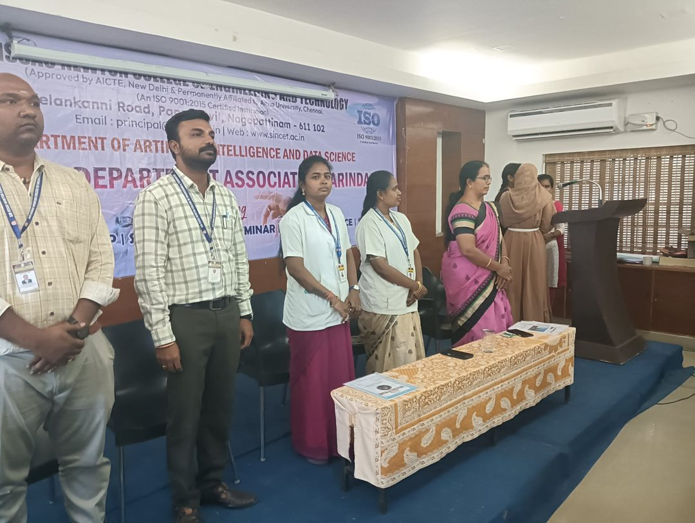

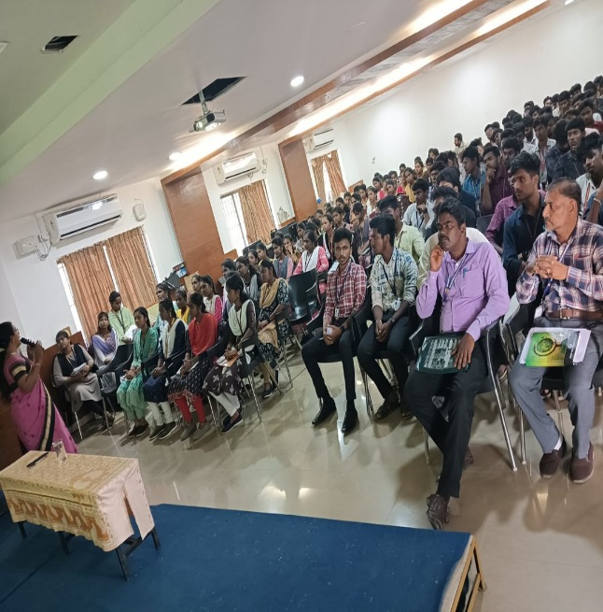 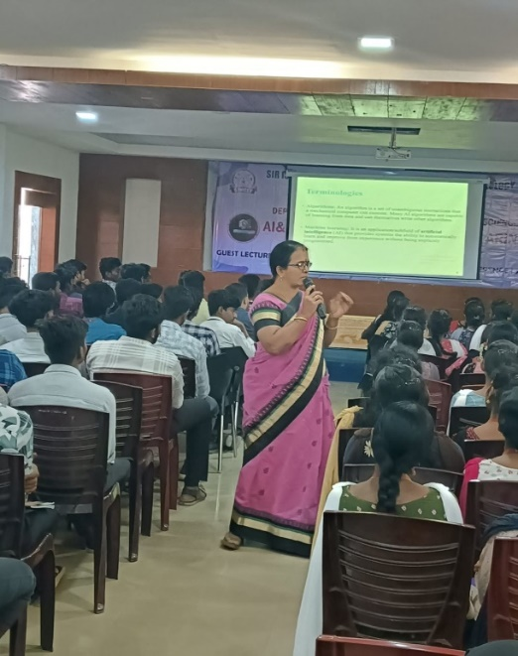

**FEED BACK ANALYSIS**