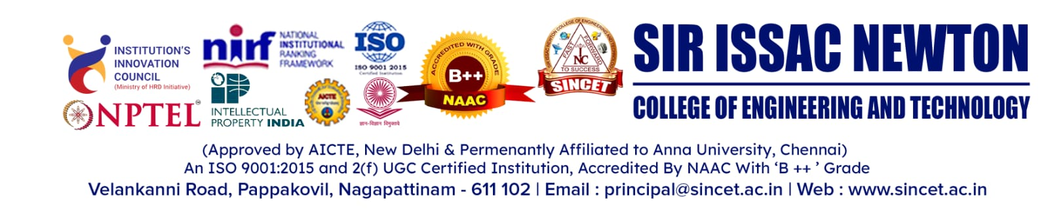

**DEPARTMENT OF ARTIFICIAL INTELLIGENCE AND DATASCIENCE**

**WEBINAR**

**Co-ordinator: Ms.R.SINDHUJA, AP/ AI&DS**

**REPORT**

The Department of Artificial Intelligence and Data Science at Sir Issac Newton College of Engineering and Technology, in association with the AI&DS Association ARINDASCI, conducted a webinar for all II YR and III YR AI&DS students and faculty. The program held on March 13, 2025 from 10.00 am to 12.00 pm

The program began with a welcome address by Mrs. K. Maheshwari, HOD of AI&DS, where she introduced the resource person, Dr.E.Elakkiya, M.E., Ph.D., Assistant Professor (Senior Grade-2) at Vellore Institute of Technology, Chennai. Dr.E. Elakkiya delivered a session titled "Unlock Data Insights with Weka Tool". She presented the latest updates on machine learning using the WEKA tool, integrating artificial intelligence concepts.

The session was highly informative, engaging students in hands-on exercises with Weka Explorer. The event concluded with a vote of thanks delivered by the coordinator,

Ms. R. Sindhuja, AP/AI&DS.

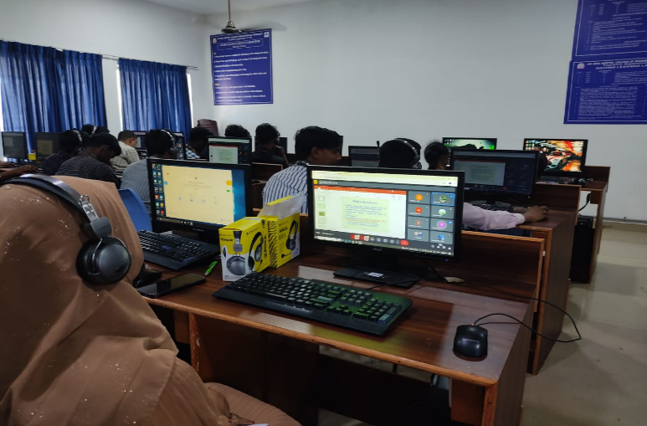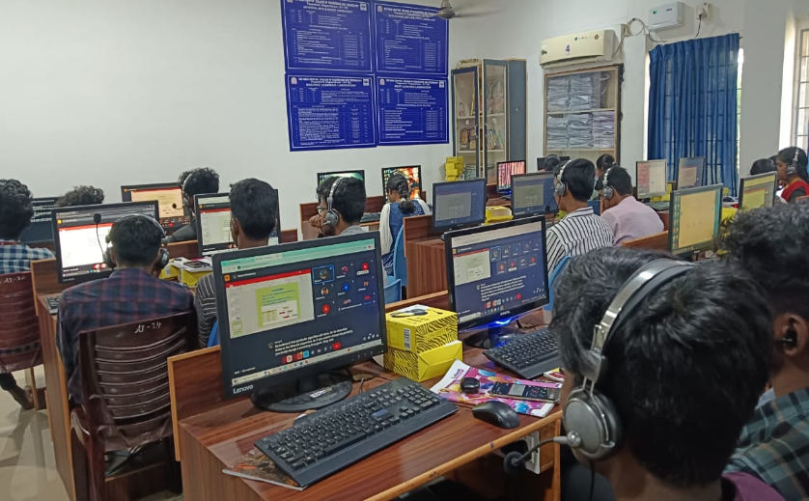**WEBINAR -PHOTOS**

