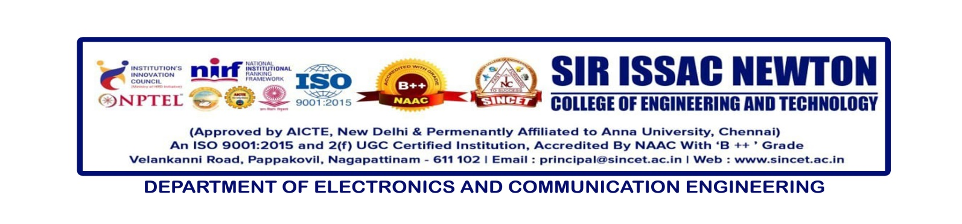

**Internal Seminar** : **X-MAX Technology**

**Date : 30-11-2024**

**Resource Person : Prof .P.Navaneethakrishnan, AP/ECE**

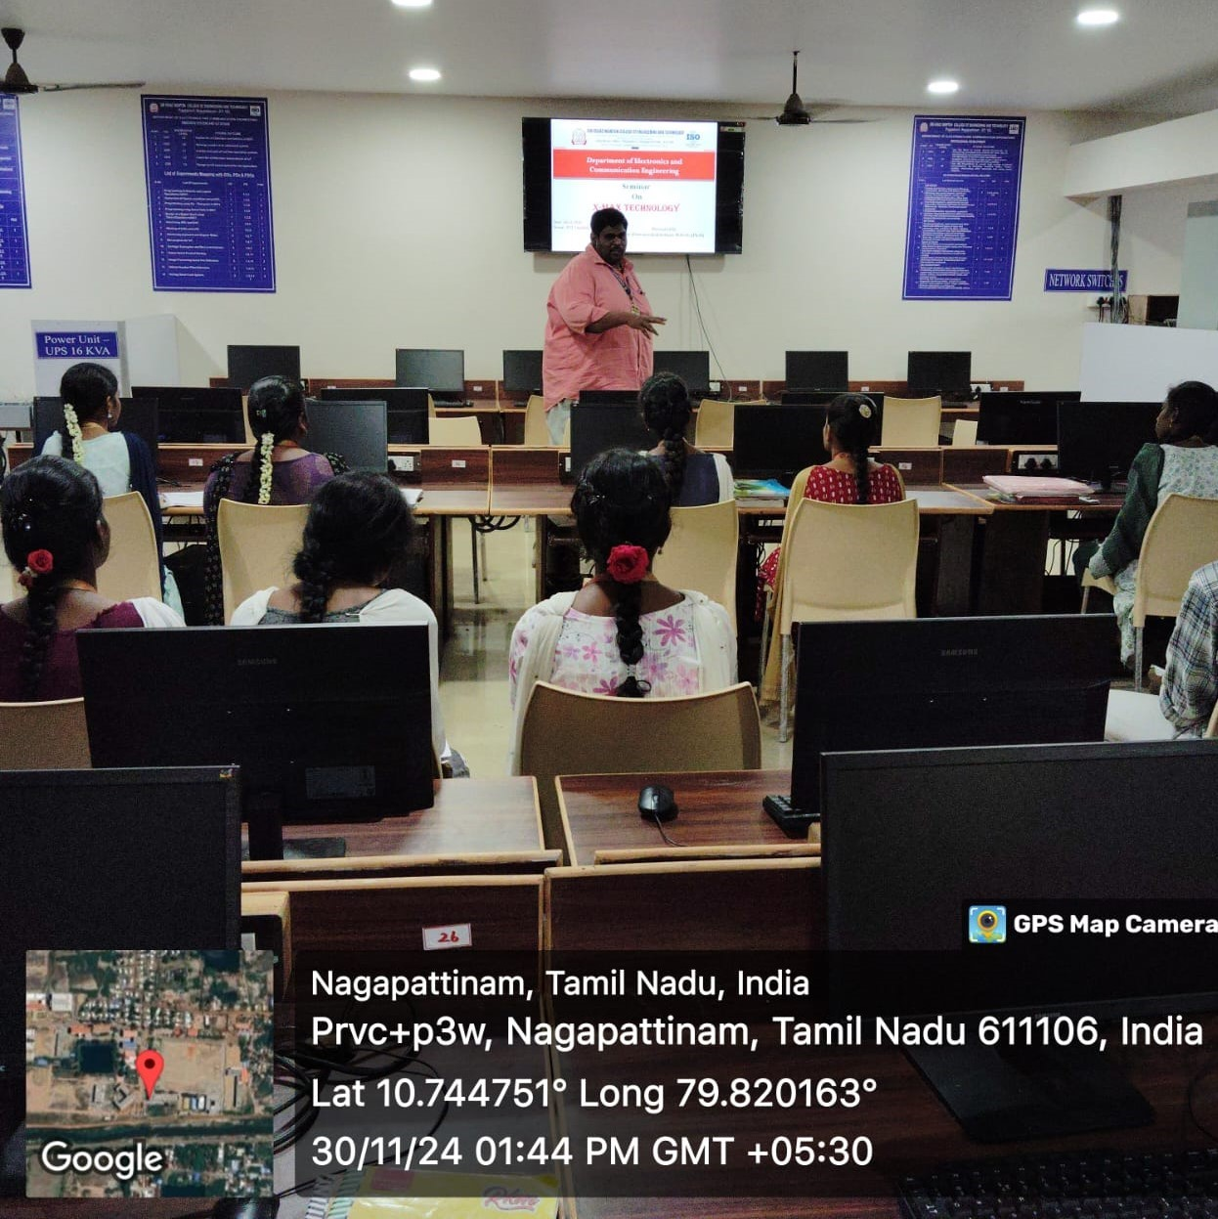

The Department of Electronics and Communication Engineering (ECE) organized an internal seminar on "X-MAX Technology" on **September 12, 2024**. The event was held at the ECE Computer Centre, with **Prof. P. Navaneethakrishnan**, Head of the ECE Department, serving as the resource person.

The seminar witnessed enthusiastic participation from students of the **second and third years** of the ECE department, with a total of **75 students** attending the session. The event provided valuable insights into the advancements and applications of X-MAX technology, equipping students with knowledge relevant to cutting-edge developments in the field of electronics and communication.

This initiative reflects the department's commitment to fostering academic excellence and keeping students abreast of emerging technological trends.