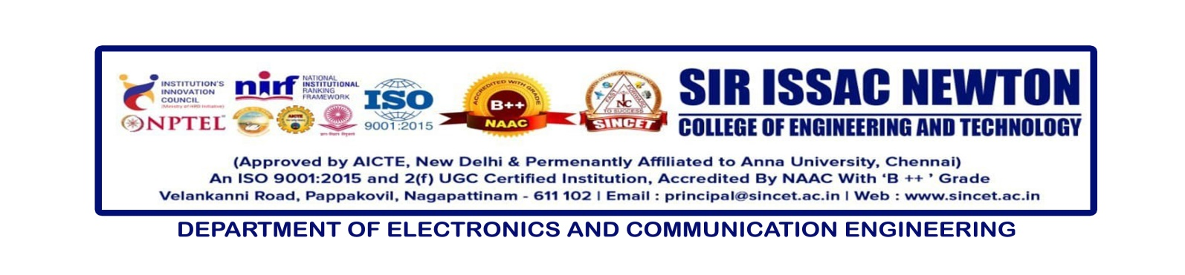

**Internal Seminar** : **Effective Research Paper Writing and Avoiding Plagiarism Pitfalls**

**Date : 12-09-2024**

**Resource Person : Prof .P.Navaneethakrishnan, AP/ECE**

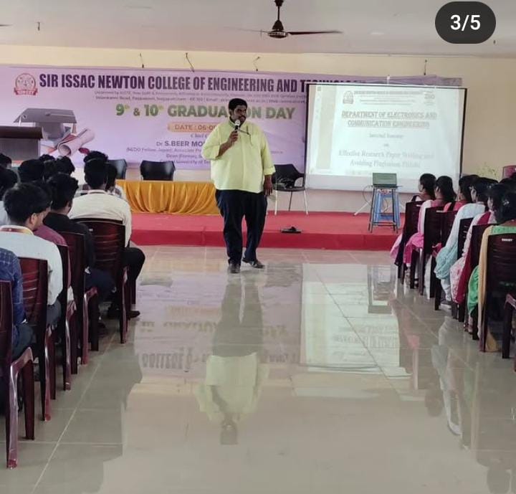

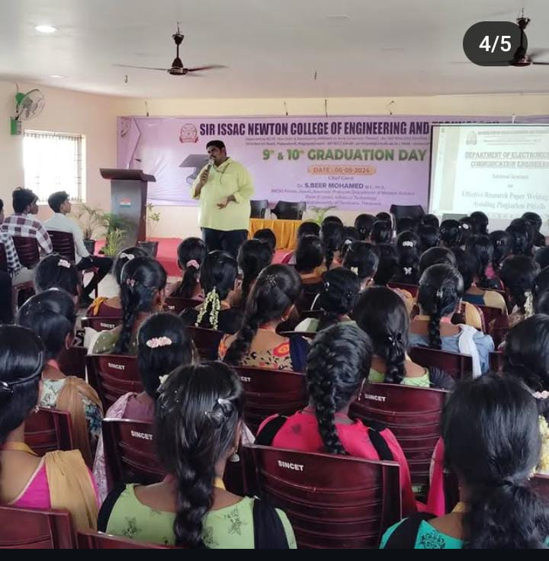

An insightful seminar titled “**Effective Research Paper Writing and Avoiding Plagiarism Pitfalls**” was organized by the Department of Electronics and Communication Engineering on 12th September 2024 at the SINCET Auditorium. The session was led by the esteemed Prof P. Navaneethakrishnan, Head of the Department, ECE.

The seminar witnessed enthusiastic participation from **120** students across II, III, and IV-year ECE batches. Prof. Navaneethakrishnan shed light on the essential techniques of crafting impactful research papers while emphasizing the significance of academic integrity and methods to avoid plagiarism.

The event provided students with valuable insights into scholarly writing and ethical research practices, equipping them with the tools necessary for success in their academic and professional endeavors.