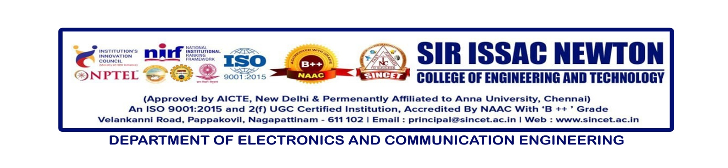

**Internal Seminar** : **Electronics Fundamentals**

**Date : 02-01-2025**

**Resource Person : Prof .P.Navaneethakrishnan, AP/ECE**

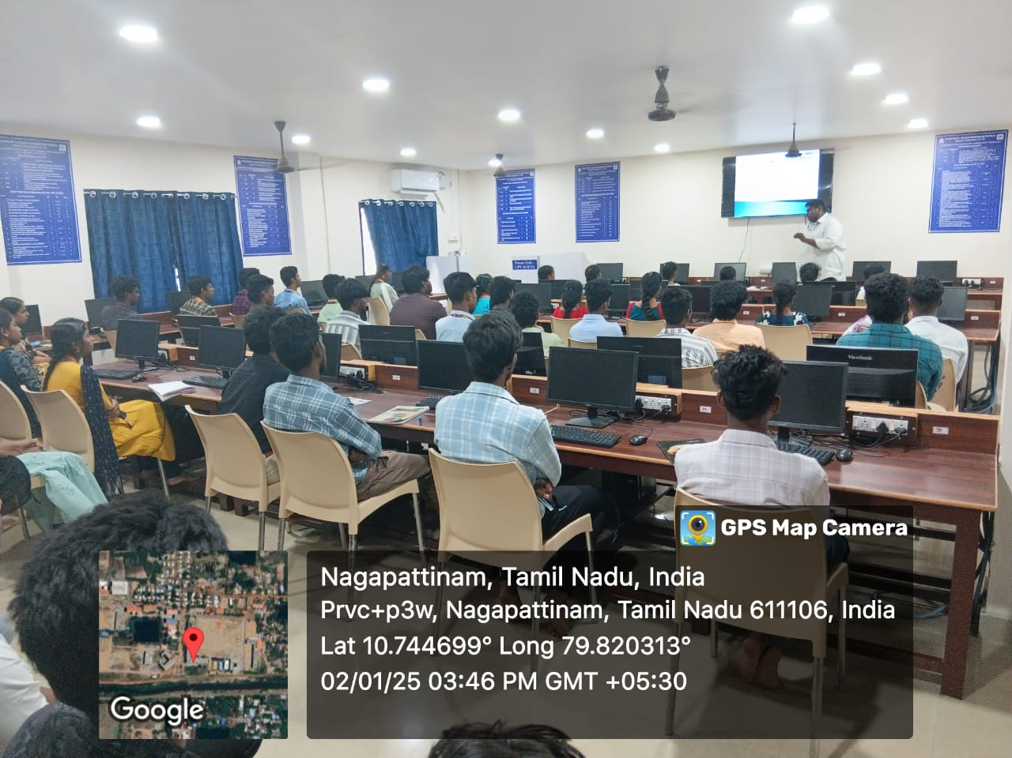

The Department of Electronics and Communication Engineering (ECE) hosted an internal seminar on **"Electronics Fundamentals"** on **02 January 2025** at the ECE Computer Centre. The seminar was led by **Prof. P. Navaneethakrishnan**, Head of the Department, ECE, as the resource person.

This seminar was organized to enhance the foundational understanding of electronics among the **first-year ECE students (S&H)**. A total of **46 students** actively participated, engaging in interactive discussions and practical demonstrations.

The event provided a platform for the students to deepen their knowledge in core electronics principles, setting a strong foundation for their academic and professional growth.

The department extends its gratitude to Prof. P. Navaneethakrishnan for his valuable insights and the students for their enthusiastic participation.