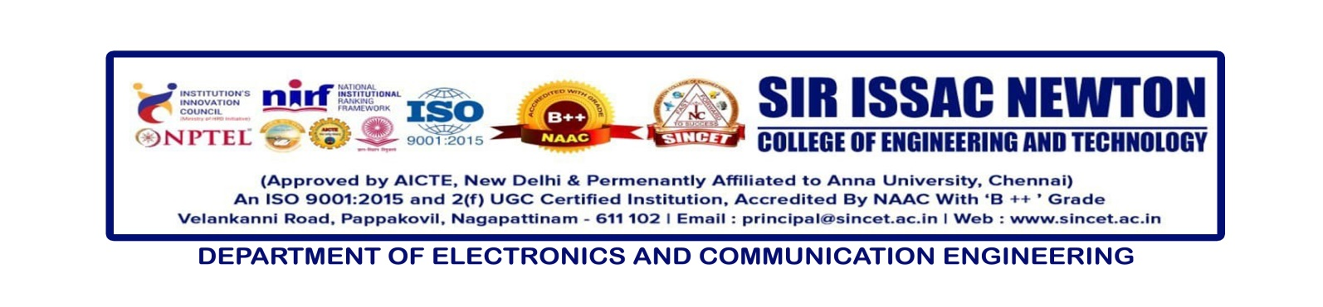

**Internal Seminar** : **Storage Area Network (SAN)”**

**Date : 13-12-2024**

**Resource Person : Prof .P.Navaneethakrishnan, AP/ECE**

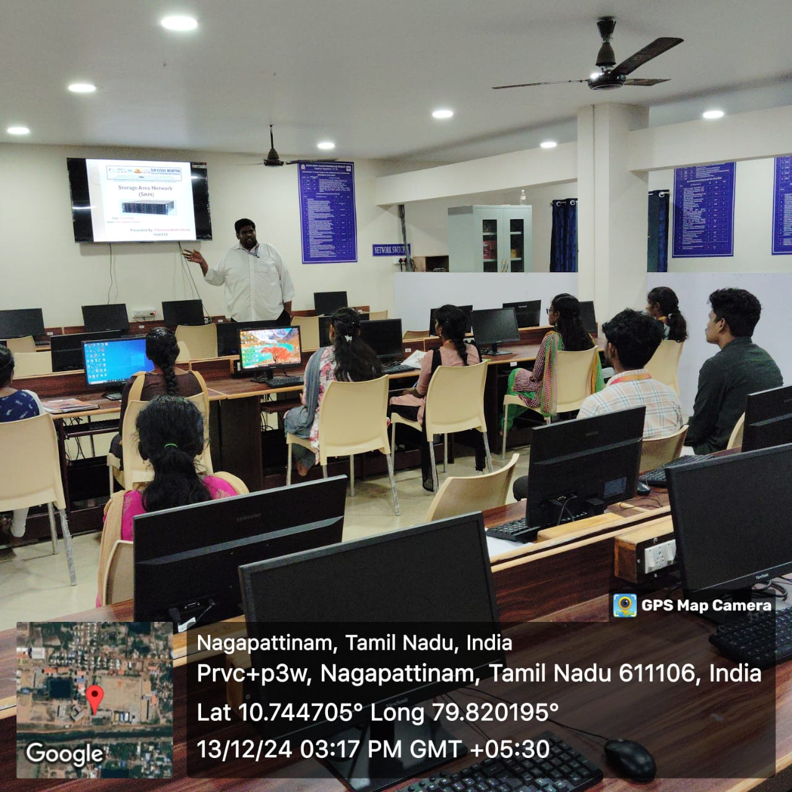

The Department of Electronics and Communication Engineering (ECE) successfully conducted an internal seminar on **“Storage Area Network (SAN)”** on **13th December 2024**. The seminar was held at the ECE Computer Centre, with Prof. P. Navaneethakrishnan, Head of the Department (HoD) of ECE, serving as the resource person.

The event was attended by **88 students** from the **III and IV year ECE batches**, who actively participated and engaged in discussions on SAN technology and its applications. Prof. Navaneethakrishnan delivered an insightful session, providing a comprehensive understanding of the principles, architecture, and significance of SAN in modern data management and computing.

The seminar aimed to enhance the technical knowledge and practical understanding of students, preparing them for industry-related challenges in data storage and networking. The session concluded with an interactive Q&A segment, where students had the opportunity to clarify their doubts and explore the latest advancements in SAN technologies.

This initiative reflects the department’s commitment to fostering technical excellence and bridging the gap between academia and industry.