DEPARTMENT OF INFORMATION TECHNOLOGY

Teachers’ Day Celebration Report

Date: 04.09.2025
Venue: Sir Issac Newton College of Engineering and Technology auditorium
Organized by: Department of Information Technology (IT Students)
The Teachers’ Day celebration for the academic year 2025 was held on 4th September 2025 at Sir Issac Newton College of Engineering and Technology. The program was organised by the students of the Department of Information Technology to honour and appreciate the dedication, guidance, and contributions of all the faculty members.
. The event begins with a warm welcome address by the student coordinators, followed by a ceremonial lighting of the lamp. Students expressed their gratitude through speeches, poems, and short cultural performances. A special video presentation was also showcased highlighting memorable moments with the faculty. The event aimed to honour principal, vice-principal , HODs and staff members.
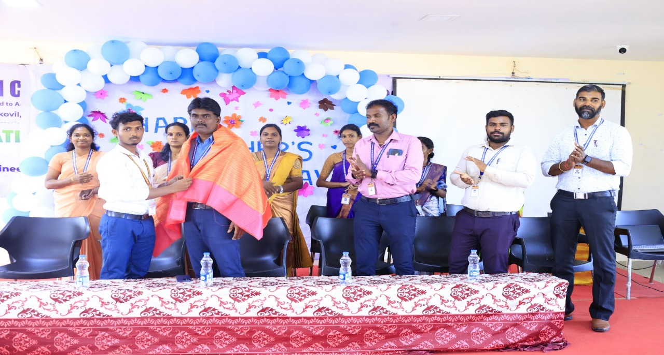

Various fun activities and games were conducted for the Staff members, which added joy and liveliness to the celebration. The faculty members participated enthusiastically and appreciated the efforts taken by the students.

The Head of the Department addressed the gathering and encouraged the students to continue their hard work and uphold the values of the institution. The celebration concluded with a vote of thanks delivered by a final-year student, followed by a group photo session and refreshments.
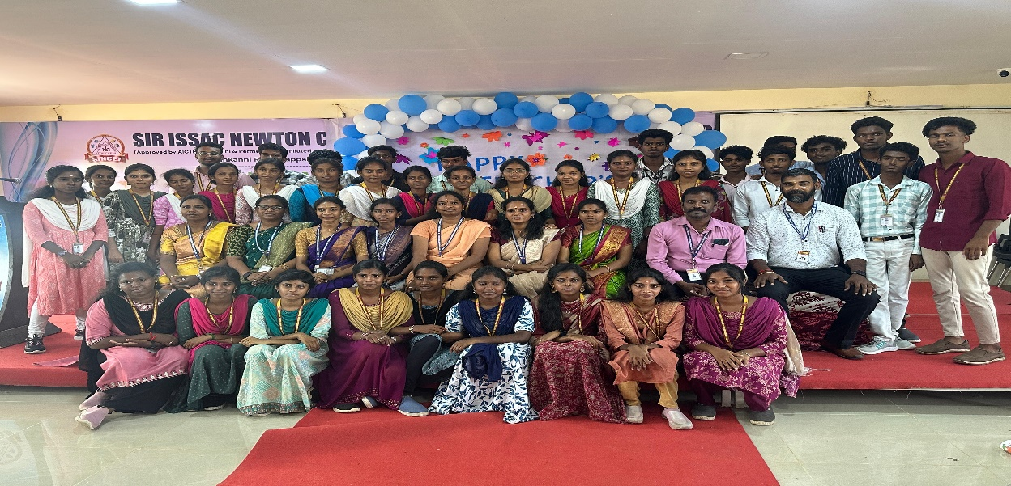

Overall, the Teachers’ Day celebration was a heartfelt tribute to the mentors who shape the future of students. The event was successful and memorable, reflecting the strong bond between faculty and students

