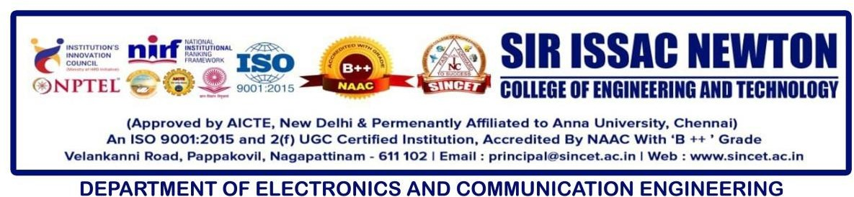

Program Objective
Two days workshop on
PCB Design Process and Prototyping

The main objective of the Two-Day Hands-on Workshop on “PCB Design Process and Prototyping” was to provide students with practical exposure to the design, simulation, and fabrication process of Printed Circuit Boards (PCBs).

The workshop aimed to:
- Familiarize students with PCB design tools and software.
- Demonstrate the complete PCB design flow - from circuit schematic to prototype fabrication.
- Develop technical skills in circuit simulation, component selection, and board layout design.
- Encourage interdisciplinary learning and teamwork among students from various departments.

A two-day hands-on workshop on “PCB Design Process and Prototyping” was organized by the Department of Electronics and Communication Engineering (ECE) in association with ISTE at Sir Isaac Newton College of Engineering and Technology on October 24 and 25, 2025.

The objective of the workshop was to provide students with practical exposure to the design and development of Printed Circuit Boards (PCBs). A total of 100 students from various departments including ECE, IT, Science & Humanities, Mechanical Engineering, and AI & DS actively participated in the event.

The inaugural function featured a Welcome Address by the Head of the ECE Department, a Presidential Address by the Principal, and a Chief Guest Address by the Registrar. Mr. S. Saran, Operational Manager of Ematix Embedded and Software Solutions Pvt. Ltd., Salem, delivered the Facilitation Address.

Participants received detailed training and hands-on experience in simulation drawing, PCB layout design, and circuit board prototyping through four interactive sessions held over two days:

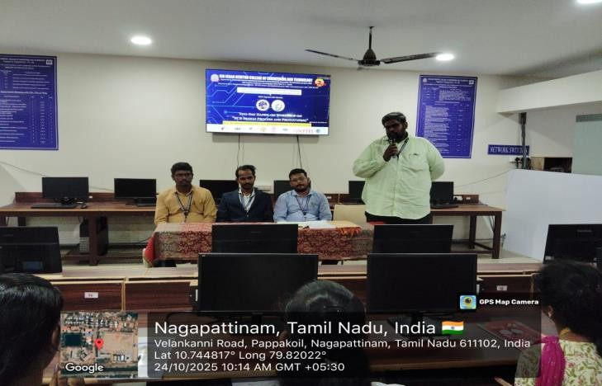
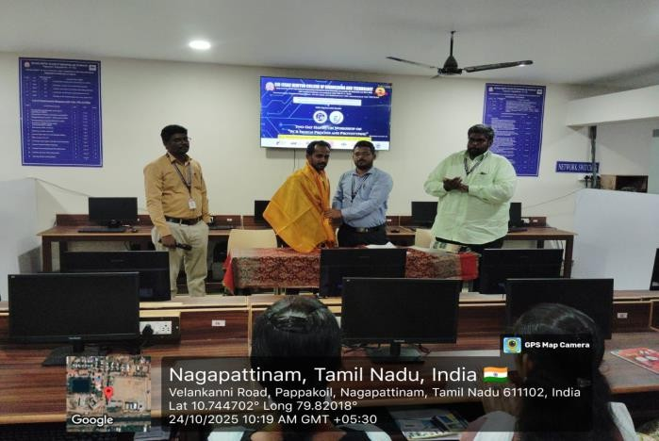
- Session 1 (24-10-2025): Fundamentals of PCB, types, design flow, and tools overview
- Session 2 (24-10-2025): Circuit creation, component selection, ERC check, and netlist generation
- Session 3 (25-10-2025): Board setup, component placement, routing techniques, and DRC check
- Session 4 (25-10-2025): Gerber file generation, PCB fabrication process, and safety handling
The event concluded with a Vote of Thanks delivered by the Event Coordinator, followed by the distribution of certificates to all participants, marking the successful completion of the workshop.
Program Outcomes
After successful completion of the workshop, the participants were able to:

- Understand the fundamentals and step-by-step process of PCB design and prototyping.
- Design and simulate electronic circuits using industry-standard PCB design software.
- Perform ERC (Electrical Rule Check), DRC (Design Rule Check), and generate Netlist and Gerber files.
- Apply knowledge to develop and test PCB prototypes effectively.
- Follow safety procedures during PCB fabrication and handling.
- Demonstrate improved problem-solving and practical implementation skills relevant to electronic design.
- Collaborate efficiently in interdisciplinary teams, strengthening both technical and communication abilities.

